**s o f i a**

**GUI & Design**

*End of Iteration 1 – GUI & Design*

**Document Control**

|  |  |  |
| --- | --- | --- |
| **Editor** | **Date** | **Update** |
| **Lewis Thresh** | **11/03/2015** | **Created and wrote document.** |
|  |  |  |
|  |  |  |

**Table of Contents**

[1. Summery 4](#_Toc413860227)

[2. GUI 4](#_Toc413860228)

[I. Initial Wireframes (LearnEasy) 4](#_Toc413860229)

[II. Prototypes 5](#_Toc413860230)

[III. Iteration 1 GUI 6](#_Toc413860231)

[3. Logos Versions 7](#_Toc413860232)

[4. Company Logo Versions 8](#_Toc413860233)

# Summery

For iteration 1 we have produced a simple GUI for our LearnEasy application, an application logo for both TeachEasy and LearnEasy and our company logo. This document shows the evolution of each one of these so far.

# GUI

## Initial Wireframes (LearnEasy)

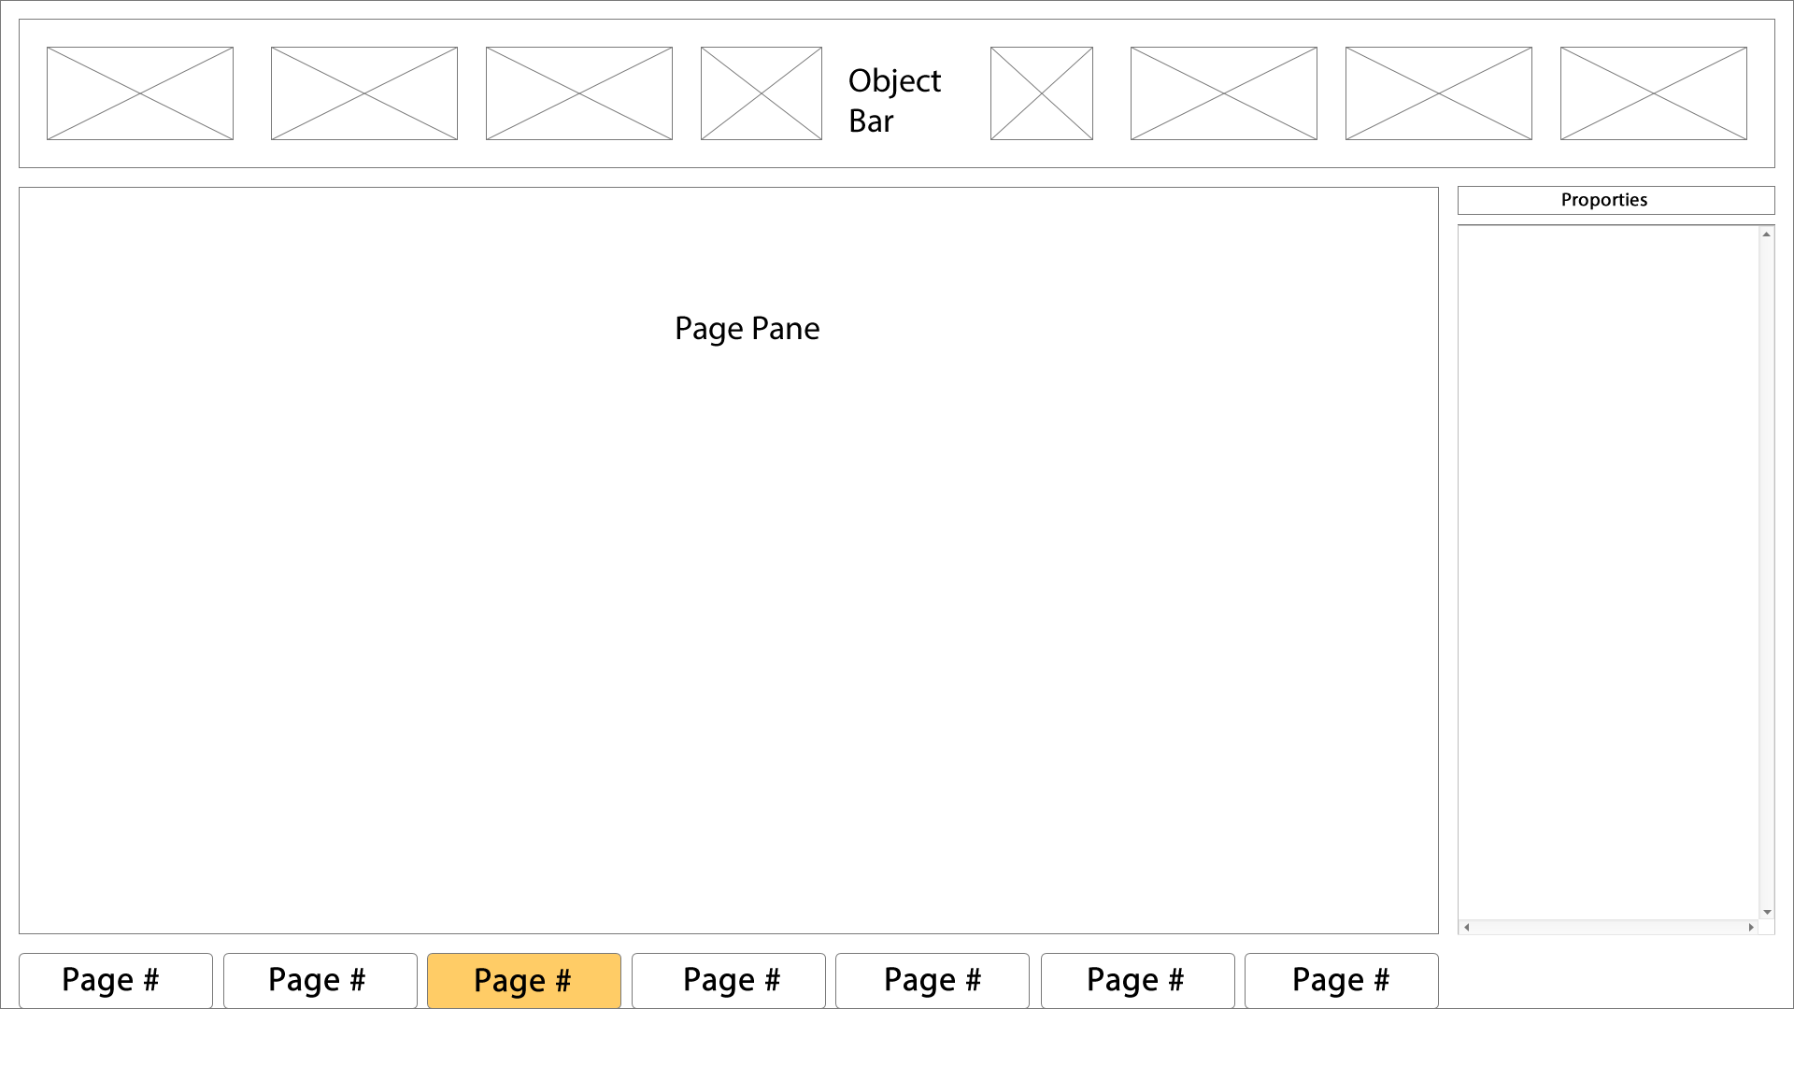

Figure 1 – Initial TeachEasy wireframe

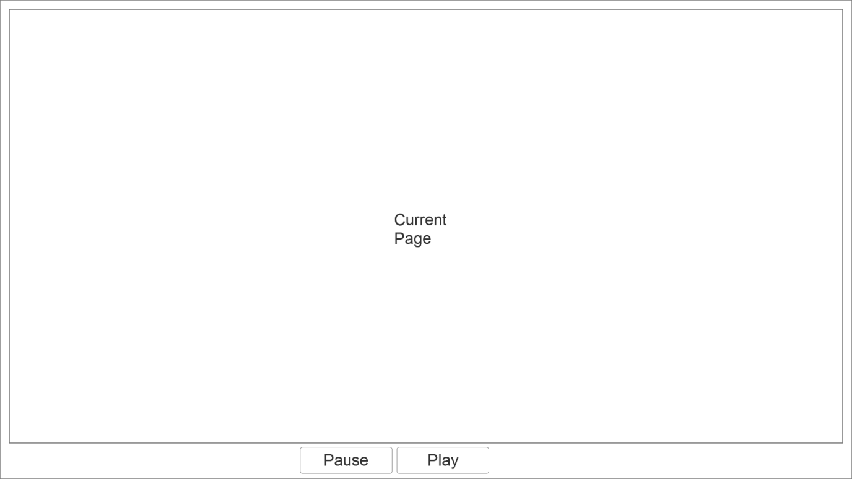

Figure 2 – Initial video player wireframe

## Prototypes

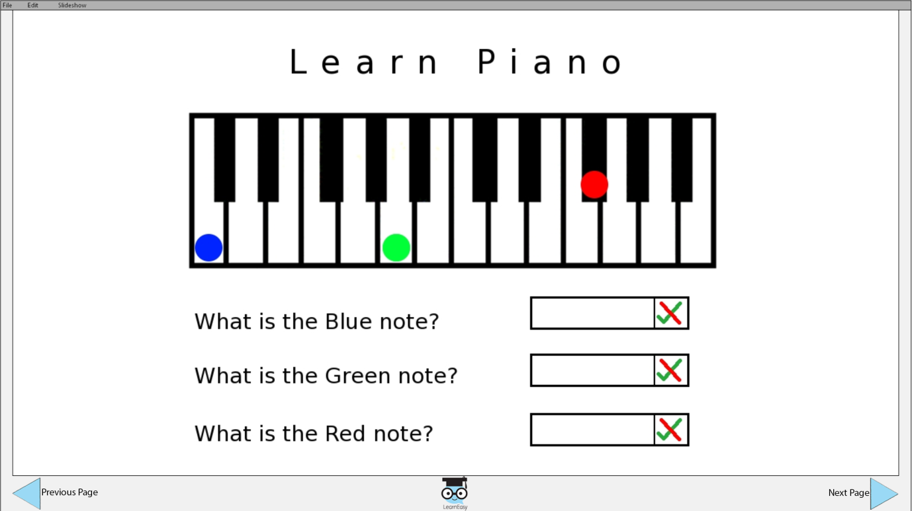

Figure 3 – LearnEasy prototype GUI

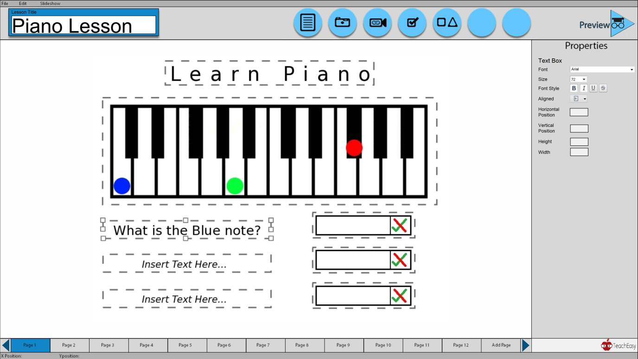

Figure 4 – TeachEasy prototype GUI

## Iteration 1 GUI

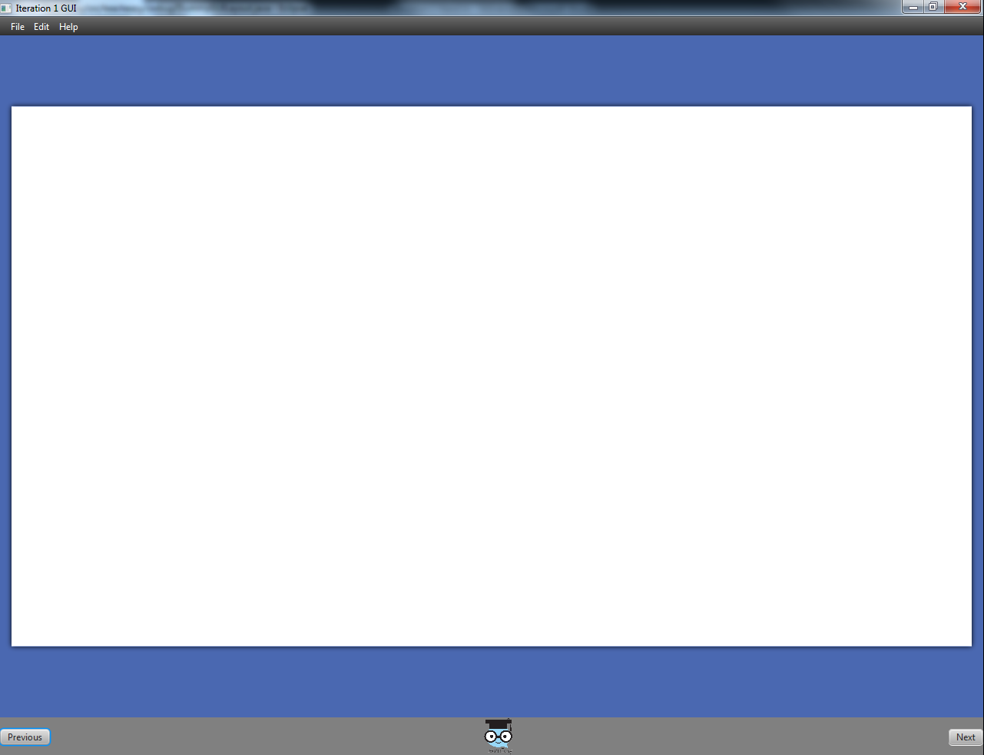

# Logos Versions

|  |  |
| --- | --- |
| Logo and version number |  |
| LearnEasy - Version 1 | \\userfs\lt669\w2k\Desktop\SWENG - GUI Handin\Logo iterations\Logo iterations\Learneasy_v1.png |
| LearnEasy – Version 2  Whitened out eyes to match TeachEasy V.4  Also removed background colour (White) | \\userfs\lt669\w2k\Desktop\SWENG - GUI Handin\Logo iterations\Logo iterations\Learneasy_v2.3.png |
| TeachEasy preview icon for TeachEasy GUI prototype  Based on LearnEasy logo as the preview function allows them to view the lesson as a student would | \\userfs\lt669\w2k\Desktop\SWENG - GUI Handin\Logo iterations\Logo iterations\Learneasy_v3.png |

|  |  |
| --- | --- |
| Logo and version number |  |
| TeachEasy – V.1  Originally designed to look like LearnEasy | \\userfs\lt669\w2k\Desktop\SWENG - GUI Handin\Logo iterations\Logo iterations\Teacheasy_v2.png |
| TeachEasy – V.2  Changed the ‘character’ | \\userfs\lt669\w2k\Desktop\SWENG - GUI Handin\Logo iterations\Logo iterations\Teacheasy_v2.2.png |
| TeachEasy –V.3  Changed text to match LearnEasy for continuity | \\userfs\lt669\w2k\Desktop\SWENG - GUI Handin\Logo iterations\Logo iterations\Teacheasy_v1.2.png |
| TeachEasy – V.4  Changed colour of glasses frames to match LearnEasy  Also removed background colour (White) | \\userfs\lt669\w2k\Desktop\SWENG - GUI Handin\Logo iterations\Logo iterations\Teacheasy_v2.3.png |

# Company Logo Versions

|  |  |
| --- | --- |
| First two company logo ideas.  Logo [2] was used for the initial QA manual. | \\userfs\lt669\w2k\Desktop\SWENG - GUI Handin\Company Logo Iterations\Company Logo Iterations\Logo_v1.jpg\\userfs\lt669\w2k\Desktop\SWENG - GUI Handin\Company Logo Iterations\Company Logo Iterations\Logo_v2.jpg  [2]  [1] |
| New company logo designed based on the Grek spelling of Sofia | \\userfs\lt669\w2k\Desktop\SWENG - GUI Handin\Company Logo Iterations\Company Logo Iterations\sofia logo013.jpg\\userfs\lt669\w2k\Desktop\SWENG - GUI Handin\Company Logo Iterations\Company Logo Iterations\Sofia-Greek.jpeg |
| More detailed version of the new logo with added English spelling at the bottom for clarity of our company name and blending the bottom text in with the logo | \\userfs\lt669\w2k\Desktop\SWENG - GUI Handin\Company Logo Iterations\Company Logo Iterations\sofia logo_2.2xcf.png |
| Movement of text position to make it look central to the logo | \\userfs\lt669\w2k\Desktop\SWENG - GUI Handin\Company Logo Iterations\Company Logo Iterations\sofia logo_2.3xcf.png |